At PRAC Financial, we value your feedback. We ensure you are treated fairly and deliver a good outcome.

Please note that BW Legal are authorised to handle complaints on behalf of PRAC Financial. You may be contacted by BW Legal regarding your complaint.

**Making A Complaint**

You can make a complaint about us directly to BW Legal. You can contact BW Legal through:

<https://www.bwlegal.co.uk/help/contact-us>

<https://portal.bwlegal.co.uk/Account/Login?ReturnUrl=%2F>



0113 487 0430



BW Legal, Enterprise House, 1 Apex View, Leeds, LS11 9BH

**Complaints Procedure**

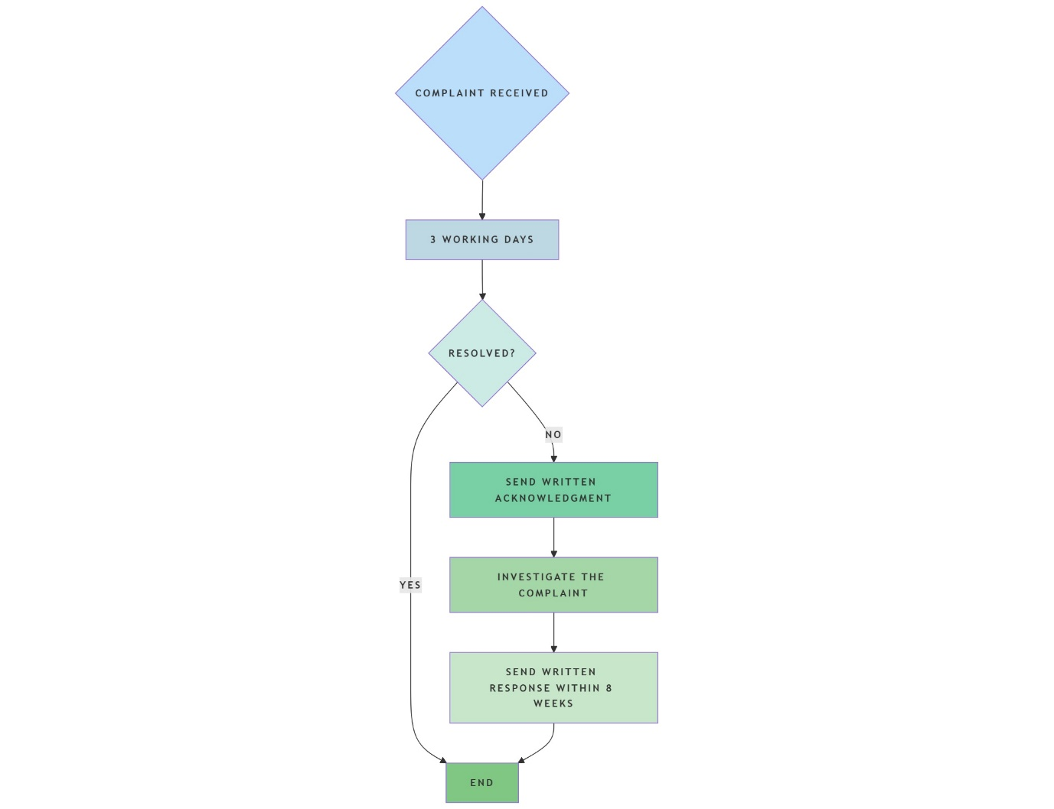

If you remain unhappy, please contact BW Legal who will review your complaint and respond to your concerns on our behalf.

In some cases, you may have the right to refer the matter to the Information Commissioner’s Office ([www.ico.org.uk](http://www.ico.org.uk); 0303 123 1113).